**Total Banking Fraud**

**Treasonous Political Parties removed all the living from their Acts in 1973**

**and created us all as Statutory entities = JOHN DOE & JANE DOE**

**This Royal Commission is a total Fraud**

The Royal Commission into Misconduct in the Banking, Superannuation and Financial Services Industry (Financial Services Royal Commission) was established in **December 2017.**

NOW THEREFORE We do, by Our Letters Patent issued in Our name by Our Governor-General of the Commonwealth of Australia on the advice of the Federal Executive Council and under the Constitution of the Commonwealth of Australia, the *Royal Commissions Act 1902* and every other enabling power, appoint you to be a Commission of inquiry, and require and authorise you, to inquire into the following matters:

*Statutory, Law and Justice Legislation Amendment Act 1988* (Cth) Act No. 120 of 1988

which amended Judiciary *Act* 1903 No 6. *This is Total Treason and the Political Parties*

Section 80, **Common Law to Govern,** *High**Court of Australia are of knowledge as they*

replacing “common law of England”, *used 5 different common laws in one Court case.*

with “common law in Australia”. *Ignorance of the law is no defence.*

**The Fraudulent Statutory Commission for the so-called Governor-General**

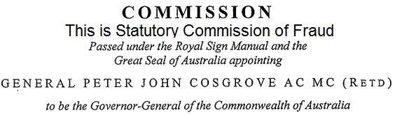



This so-called man Peter Cosgrove is a Traitor. His Commission under the Queen of Australia, the Statutory entity created by Treasonous Political Parties in 1973.

This so-called Governor-General sits in Treason and has NO Crown and Constitutional Authority. This clown is owned and controlled by Treasonous Political Parties. So-called Governor-General Cosgrove is just a Statutory Entity.

Also

By using the *Royal Commissions Act 1902,* which is a Common Law of England Act and had Crown and Constitutional Authority. Your so-called Statutory Royal Commission Act compilation is an act of Treason.

 **A Statutory Seal**

This Seal is Total Fraud.

In the original Royal Warrant this is a Public Functionary Seal to be used

“in order that our Officers of Arms and all other Public Functionaries whom it may concern may take full notice and have knowledge thereof in their several and respective departments”

The above Fraudulent Seal has the Roman laurel wreath under the Treasonous Political Parties definition of their Australia created in 1973. All Acts from 1960 forward are Statutory as they don’t have Crown and Constitutional Authority.

ELIZABETH THE SECOND, by the Grace of God Queen of Australia and Her other Realms and Territories, Head of the Commonwealth:

TO

The Honourable Kenneth Madison Hayne AC QC

*Treasonous Political Party definitions just in these 3 lines*

Australia, = Treasonous Political Parties Australia created in 1973.

Queen of Australia, = A Statutory entity created in 1973 by Treasonous Political Parties.

Commonwealth, = Treasonous Political Parties Commonwealth created in 1973.

Honourable, = Nothing Honourable in Treason.

AC = Order of Australia, = an act of selling your soul to Treasonous Political Parties.

QC = Queen's Counsel, = The Question must be asked, What Queen??? As Our Primary Law Queen is

*Elizabeth the Second*

*by the Grace of God of the United Kingdom of Great Britain and Northern Ireland*

*and of Our other Realms & Territories Queen, Head of the Commonwealth,*

*Defender of the Faith*, Not the Statutory Queen of Australia created by the Treasonous Political Parties.

GREETING

WHEREAS Australia has one of the strongest and most stable banking, superannuation and financial services industries in the world, which performs a critical role in underpinning the Australian economy.

AND Australia's banking system is systemically strong with internationally recognised and world's best prudential regulation and oversight.

AND most Australians are consumers of banking, superannuation and other financial services. The superannuation system alone in Australia has created more than a $2 trillion retirement savings pool, which continues to grow rapidly and which compels all working Australians to defer income today for their retirement.

AND all Australians have the right to be treated honestly and fairly in their dealings with banking, superannuation and financial services providers. The highest standards of conduct are critical to the good governance and corporate culture of those providers.

**FACTS this is all Statutory**

**No Crown and Constitutional Authority under Statutory Seals**

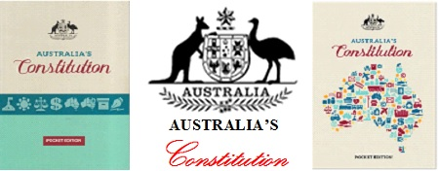

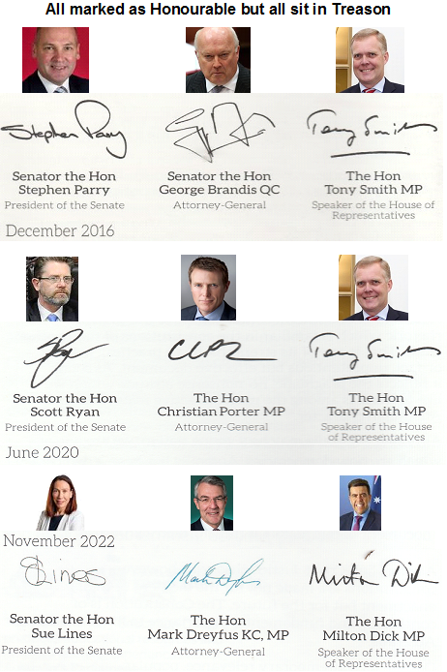

All these Treasonous so-called people above have their signatures within these Political Parties Pocket Constitutions which have © Copyrighted Our Primary Law,

**Statutory,C:\D PICS\18 Australia PP  .bmp Commonwealth of Australia Constitution Act**

**An Act to constitute the Commonwealth of Australia**

[9th July 1900] © Commonwealth of Australia. Statutory Commonwealth of Australia, NOT Ours.

***How on earth ANYONE alleging to be our elected leaders can take ownership by copyrighting and placing a Statutory Seal***

***over the PEOPLE’S CONSTITUTION.***

Get one of these Pocket Constitutions from the local so-called Federal Members Office free of Charge. Apart from the Political Parties Treasonous Seal, their © Copyright, some facts are in the Forward and Overview. Some Books are different.

**FORWARD,** Extracts.

“The Constitution is the foundation document of our nation. It “constitutes” the Commonwealth of Australia, hence its name. It creates, and provides for the fundamental public institutions of, “one indissoluble Federal Commonwealth under the Crown.”” *Interesting from 1973 the Treasonous Political Parties don’t recognise that we are,*

*one indissoluble Federal Commonwealth anymore.*

“The so-called “heads of power” are set out in s. 51. They include matters which are the particular concern of a national government – for instance, defence, taxation, currency and external affairs.” *taxation and currency ??*

*constitutional monarchy, small letters because it’s Statutory, not living.*

“Because Australia is a constitutional monarchy, the Constitution recognises the role of the Queen, and creates the office of Governor-General as “Her Majesty’s representative” who may exercise the Queen’s powers in her name.” *Political Parties don’t recognise Our Queen and her representative Governor-General as they own and control their Governor-General of their Australia with their Statutory Queen of Australia. Political Parties like to tell us, we are a Democracy where we have no rights. Being a Constitutional Monarchy we the people have every right known to man.*

“For instance, the written Constitution does not establish the office of Prime Minister, or provide for the Opposition.”

Overview, Extracts.

**“Separation of Powers**

Chapters l, ll and lll of the Constitution confer the legislative, executive, and judicial powers of the Commonwealth on three different bodies which are established by the Constitution – the Parliament (Chapter l), the Executive Government (Chapter ll), and the Judicature (Chapter lll).

**“The Crown and Responsible Government** *constitutional monarchy,**small letters*

As well as being a federation, Australia is a constitutional monarchy. Under this system of government, as the term suggests, the head of State of a country is a monarch whose functions are regulated by a constitution. The concept of the Crown pervades the Constitution. For example, the Queen is part of the Parliament (section 1), and is empowered to appoint the Governor-General as her representative (section 2). The executive power of the Commonwealth is vested in the Queen and is exercisable by the Governor-General as her representative (section 61).”

**Statutory, Commonwealth of Australia Constitution Act**

**3 Salary of Governor-General**

          3.  There shall be payable to the Queen out of the

               Consolidated Revenue fund of the Commonwealth,

               for the salary of the Governor-General,

               an annual sum which, until the Parliament otherwise provides,

               shall be ten thousand **pounds**.

**7 The Senate**

The Senate shall be composed of senators for each State, directly chosen by the people of the State, voting, until the Parliament otherwise provides, as one electorate.     **NOT BY POLITICAL PARTIES**

**24 Constitution of House of Representatives**

**The House of Representatives shall be composed of members directly**

**chosen by the people of the Commonwealth, and the number of such**

**members shall be, as nearly as practicable, twice the number of the**

**senators.         NOT BY POLITICAL PARTIES**

**42 Oath or affirmation of allegiance**

          Every senator and

                every member of the House of Representatives

                shall before taking his seat

                make and subscribe before the Governor-General,

                or some person authorised by him,

                an **oath or affirmation of allegiance**

                in the form set forth in the **schedule to this Constitution**.

***No Politician within these Treasonous Political Parties has sworn the correct Oath****.*

**46. Penalty for sitting when disqualified**

Until the Parliament otherwise provides,

                any person declared by this Constitution to be incapable of sitting as

                a senator or as a member of the House of Representatives shall,

                for every day on which he so sits,

                be liable to pay the sum of one hundred **pounds**

**to any person who sues for it in any court of competent jurisdiction.**

***This proves all Courts belong to Treasonous Political Parties, No Crown and Constitutional Authority.***

**48 Allowance to members:**

          48.Until the Parliament otherwise provides,

                each senator and each member of the House of Representatives shall

                receive an allowance of four hundred **pounds** a year,

 ` to be reckoned from the day on which he takes his seat.

**58 Royal assent to Bills**

When a proposed law passed by both Houses of the Parliament is

presented to the Governor-General for the Queen’s assent, he shall

declare, according to his discretion, but subject to this Constitution, that he

assents in the Queen’s name, or that he withholds assent, or that he

reserves the law for the Queen’s pleasure.

**66 Salaries of Ministers**

          66. There shall be payable to the Queen,

                out of the Consolidated Revenue Fund of the Commonwealth,

                for the salaries of the Ministers of State,

                an annual sum which, until the Parliament otherwise provides,

                shall not exceed twelve thousand **pounds** a year.

The Commissioner *(enforcing Treason)* submitted his final report to the Governor-General *(Sitting in Treason without Crown and Constitutional Authority )* on 1 February 2019.

The final report was tabled in the Australian Parliament *(sitting in Treason)* on 4 February 2019.

The above sections are all the same within Our Primary Law,

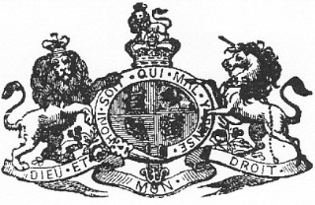

**Our Primary Law, Commonwealth of Australia Constitution Act 1901 as Proclaimed and Gazetted.**

**Political Parties are not within Our Primary Law, Commonwealth of Australia Constitution Act 1901 as Proclaimed and Gazetted**

**Political Parties corporate Commonwealth of Australia © Copyrighted Australia’s Constitution under their Queen of Australia Seal.**

**No Crown and Constitutional Authority**

***How on earth ANYONE alleging to be our elected leaders can take ownership through copyright of the***

***PEOPLE’S CONSTITUTION.***

**Financial Services Royal Commission was a Treasonous System to con the people.**

**Think People**, No body represents us,

Queen paid in Counterfeit Dollars,

Governor-General and State Governors are paid in Counterfeit Dollars,

All Political Parties are paid in Counterfeit Dollars,

The Senate and House of Representatives are paid in Counterfeit Dollars,

All naval and military defence of the Commonwealth, Federal and State Police are to maintain the laws of the Commonwealth,

No Royal Assent, Commonwealth since 1960,

No Royal Assent, State 1985,

Counterfeit Dollars Debt belongs to Treasonous Political Parties.

**All Treasonous Political Parties sit under their own private Party Constitutions therefore they don’t represent us.**

All Banks dealing with Statutory Counterfeit so-called Australian money are dealing in Fraud. This Australia created in 1973 by Treasonous Political Parties is not Our Australia as established under our Commonwealth of Australia Constitution Act 1901 as Proclaimed and Gazetted. This Trademarked Seal can be seen in every note here shown. All notes are statutory. You can’t Trademark a Royal Warrant.

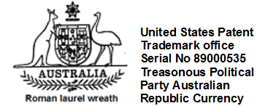

Treasonous Political Party Republican Counterfeit money.

This debt belongs to the Treasonous Political Parties and their members.

This debt doesn’t belong to the people of Our Commonwealth of Australia

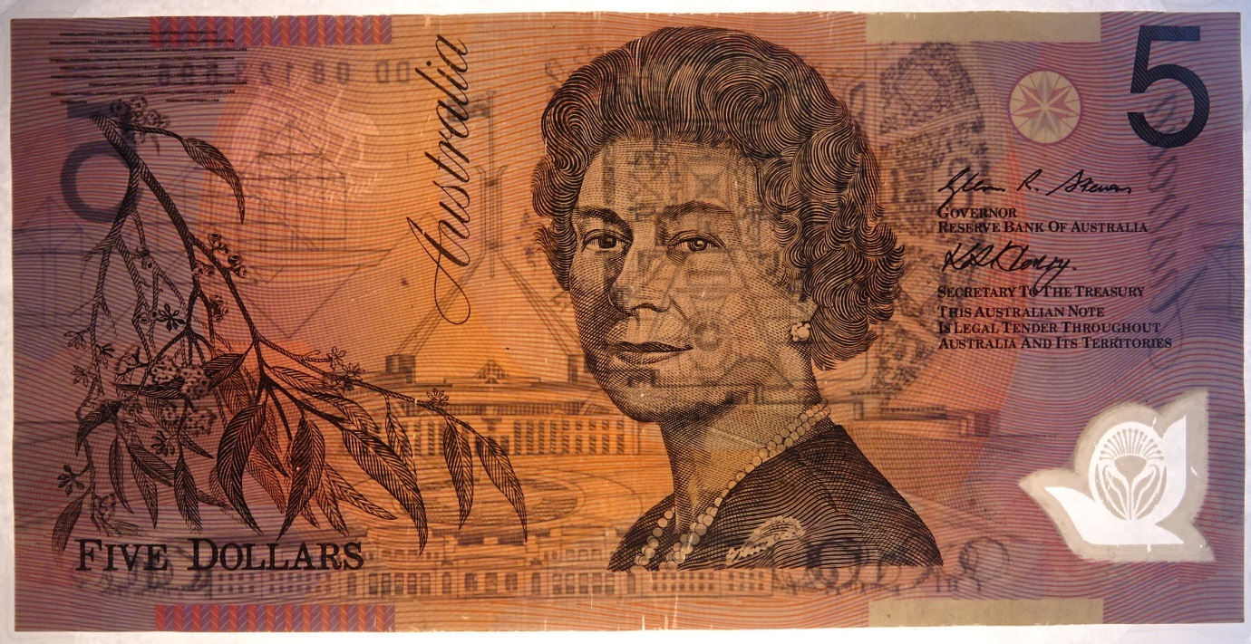

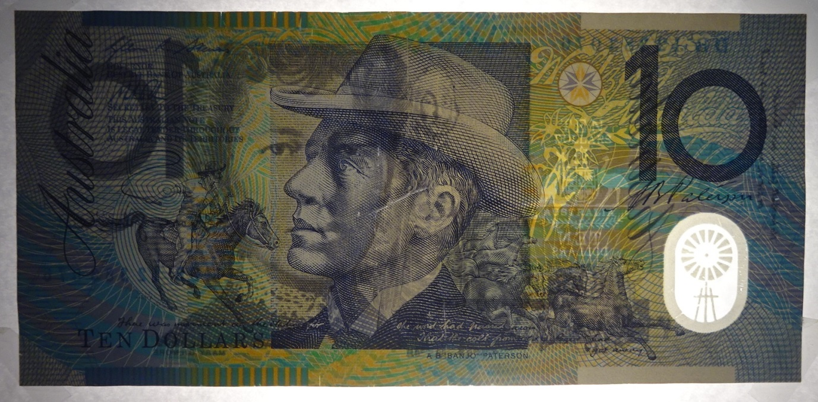

Figure 1o

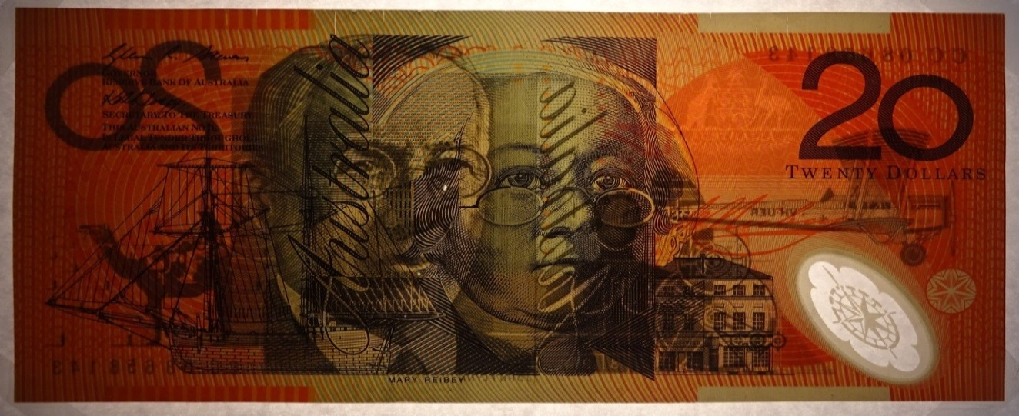

Figure 2o

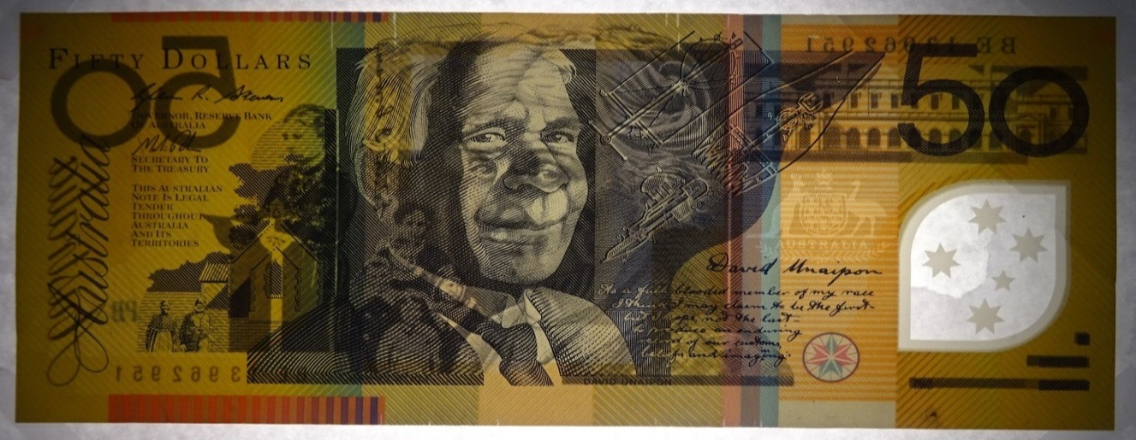

Figure 5o

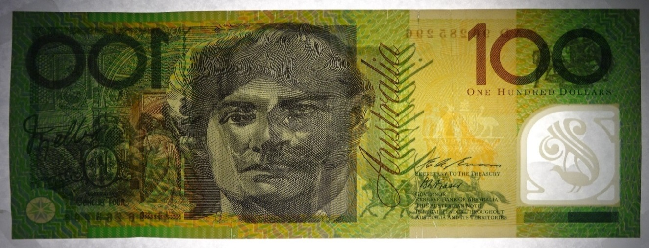

Figure 1oo

All Banks are in partnership with the Treasonous Political Parties, as you can’t have one without the other. **So what did the Treasonous Banks lend you??**

**The Treasonous Tax man, Courts, All Councils**

**are extortion rackets all charging you in**

**Counterfeit Australian Dollars. Wake up people.**

**Politics is the science of fraud, and politicians are the professors of this science.**

**The cold hard truth**

**Fraud and Treason in any Contract voids the Contract.**

**All Contracts in Dollars, Housing, property, farms, and businesses are void.**

**All Statutory Governor-Generals since 1960 and**

**All Statutory State Governors since 1965 and**

**All Statutory Parliaments, All Statutory Governments, and**

**All Statutory Banks and All Statutory Judiciary are under Treason.**

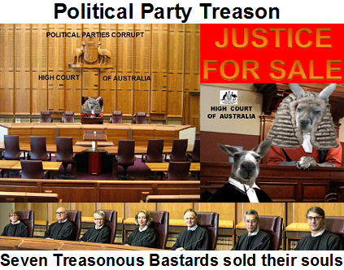

**All within the Political Parties High Court of their Australia are of knowledge as in Leask** *v* ***Commonwealth [1996]***

**they tell us the Dollar has no head of power.**

**Treason backed up by Statutory Political Party Courts and their Political power grows out of the barrel of a gun by their Federal Police Mercenaries and State Police Mercenaries, paid in counterfeit**

**Fraudulent Australian Dollars for their**

**Political Party slow coup.**

**Treason still holds the Death Penalty**

**If you can find a good cop without going to the crematory he will tell you**

**Follow the money**

I _ _  _ _  _ _ _ _ _ _ _ _ _ _ _ _ _ _ _ _ _ _ _ _ _ _ _ _ _ _ _ _ _ _ _ _ _

have transferred the guilt of knowledge of Treason to you

_ _  _ _  _ _ _  _ _ _ _ _ _ _ _ _ _ _ _ _ _ _ _ _ _ _ _ _ _ _ _ _ _ _ _ _ _

and to your heirs and successors.

**Political Parties are the Republic**

**In 1999 we voted all the Political Parties and their Republic Acts OUT and voted to stay as a Constitutional Monarchy**