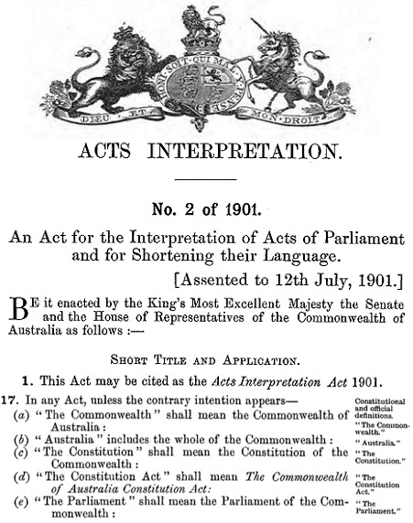

**Changed Constitutional Definitions**

**Constitutional definitions went from this**

**Our Commonwealth of Australia Constitution Act**

**is a Common Law of England Contract and**

**holds all rights known to man.**

_________________________________________________________

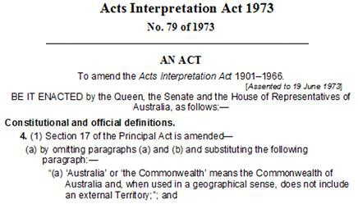

**To this Treason**

**This Act was done while sitting within the walls of OUR Parliament**

The above enacting Manner and Form has No Crown and Constitutional Authority.

The Crown and Constitutional Authority was removed in 1960 to enable Treasonous

Political Parties to create their private Corporation purportedly outside Our Primary

Law, Commonwealth of Australia Constitution Act 1901 as Proclaimed and Gazetted.

In 1960 the Politicians took ownership of the Governor-General and Commander in

Chief. This changed Our Primary Law as in Section 61 the Governor-General is the

Queens Representative. Therefore the Treasonous Politicians own and control the

purported Governor-General whom/which has lost the Authority to give Royal

Assent.

Section 58 of Our Primary Law dictates that all Acts must receive Royal Assent.

When Parliament has passed Bills they go to the Governor-Generals Office to get

Royal Assent. That involves Placing The Royal Coat of Arms and the Royal enacting

Manner and Form on the Bill which becomes an Act with Royal Assent.

Acts Interpretation Act 1973 No 79 changed the Constitutional and official definitions

creating their own Abstract Australia or Commonwealth means the Commonwealth

of Australia in Geographical Sense, outside Our Commonwealth of Australia

Constitution Act 1901 as Proclaimed and Gazetted.

in Geographical Sense,

**Oxford Dictionary**

**geographical • adj.** of or relating to geography.

**geography • n** the study of the physical features of the earth and of human activity

as it relates to these.

**sense •n.** a faculty by which the body perceives an external stimulus; one of the

faculties of sight, smell, hearing, taste, and touch **(one's senses)** one's sanity.

By these Treasonous Political Parties which are NOT within Our Primary Law,

Commonwealth of Australia Constitution Act 1901 as Proclaimed and Gazetted have

copyrighted © the above Constitution.

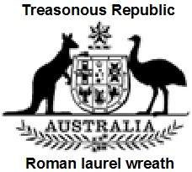

**Commonwealth of Australia Constitution Act**

**An Act to constitute the Commonwealth of Australia**

[9th July 1900]

© Copyrighted to their definition of their Commonwealth of Australia.

**Total Fraud**

This cloned Our Commonwealth of Australia Constitution Act under their changed

Constitutional definitions of Commonwealth of Australia.

Australian Electoral Act 1973 created Elections to their changed Constitutional

Definitions of Australia.

Australian Citizenship Act 1973 created abstract entities that swear their Oath to the

Political Parties Queen of Australia.

Family Court of Australia Act 1975 under Treasonous Political Parties changed

Constitutional Definitions of Australia.

Federal Court of Australia Act 1976 under Treasonous Political Parties changed

Constitutional Definitions of Australia.

Australian Federal Police Act removed the Commonwealth Police Act = changed

Constitutional Definitions of Australia.

High Court of Australia 1979 under Treasonous Political Parties changed

Constitutional Definitions of Australia.

All Acts from 1973 forward are enacted to the Queen of Australia. No Crown and

Constitutional Authority. All sitting in Treason.

**The Contrary intention has never appeared to this day.**

From this time forward 1973 all Commonwealth personal swear their Oath to the

Treasonous Political Parties abstract Queen of Australia.

After the Australian Citizenship Act creating all as abstract entities swearing their

Oaths to the Treasonous Political Parties abstract Queen of Australia.

In the 1988 Constitutional Commission, Bill No 1, it was stated that we needed that

there must be a Referendum for the Queen of Australia.

Also Bill No 2, another Referendum was needed for the Senate and Members of the

House of representatives to swear their Oath to the Queen of Australia.

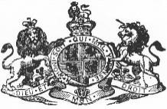

**Commonwealth of Australia Constitution Act 1901 as Proclaimed and Gazetted.**

**Part II – The Senate**

**7 The Senate**

**The Senate shall be composed of senators for each State, directly**

**chosen by the people of the State, voting, until the Parliament otherwise**

**provides, as one electorate. NOT BY POLITICAL PARTIES**

**Part III – The House of Representatives**

**24 Constitution of House of Representatives**

**The House of Representatives shall be composed of members directly**

**chosen by the people of the Commonwealth, and the number of such**

**members shall be, as nearly as practicable, twice the number of the**

**senators. NOT BY POLITICAL PARTIES**

**In 1999 we voted all the Political Party Republic Acts OUT.**

**Political Party Treason**

**A Federal Referendum of the people is an explicitly binding Act on**

**all Political Parties, Australian Governments. When Australian**

**Governments and Political Parties don’t listen to Referendums they**

**enact “TREASON” upon themselves.**