️ ***DEFICIENCIES & MISSING MINERALS & VITAMINS***

Health Secrets by Barbara O’neill

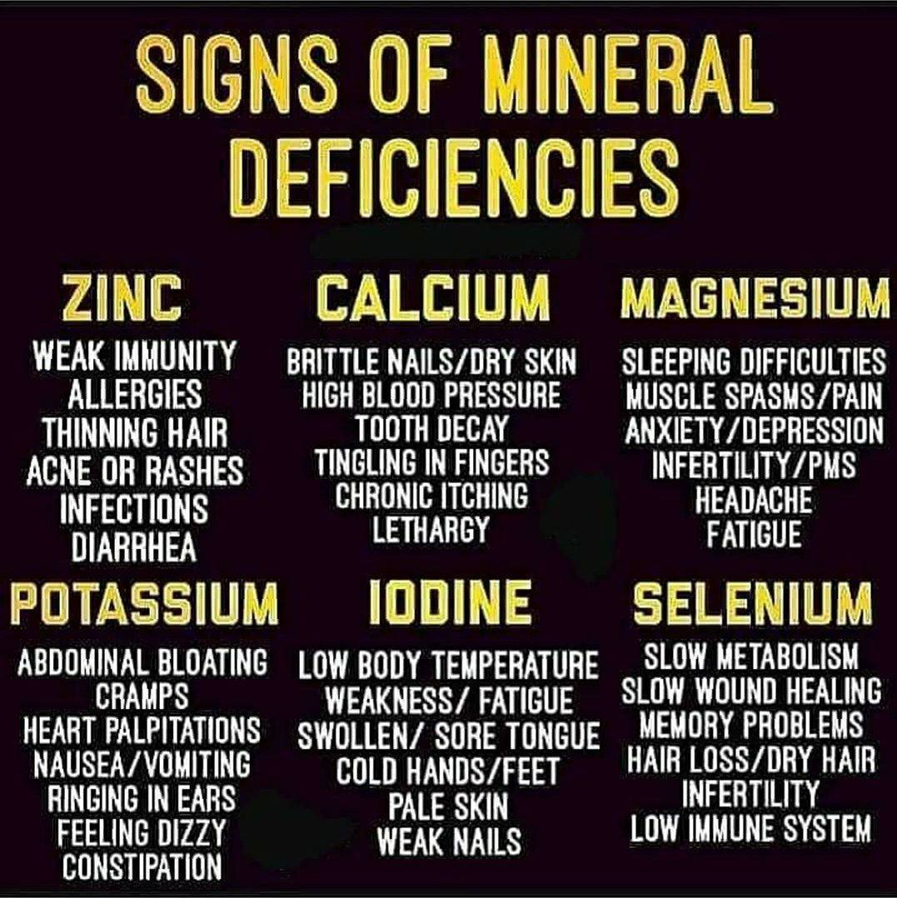

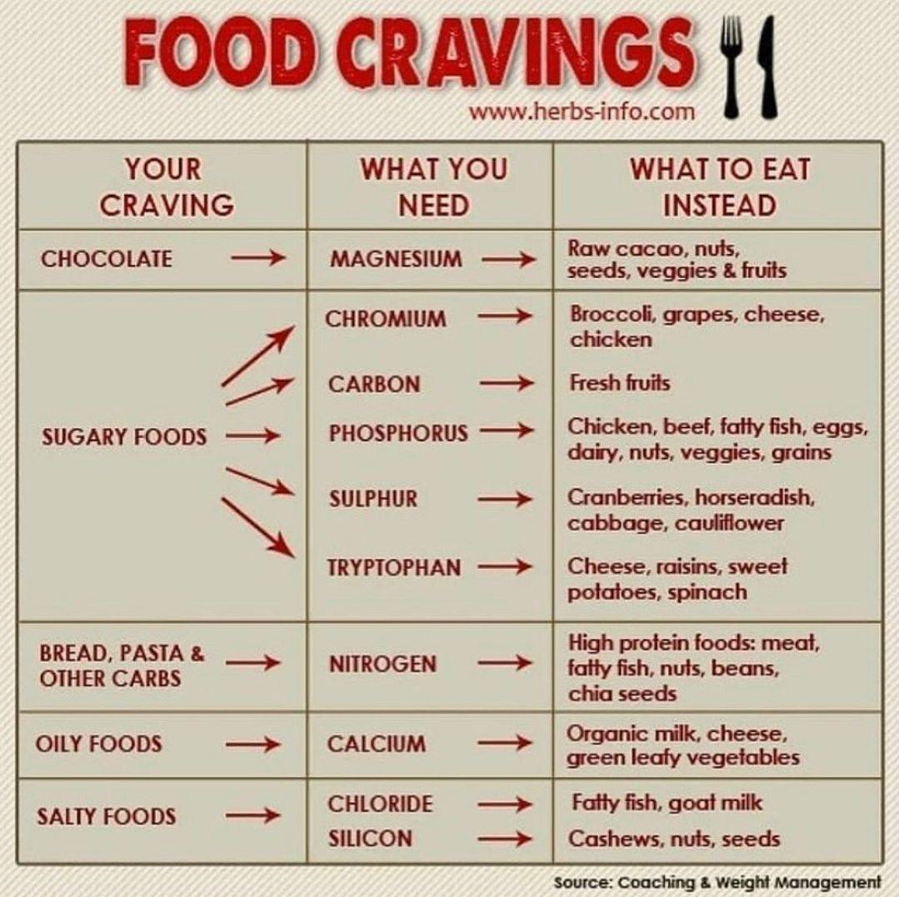

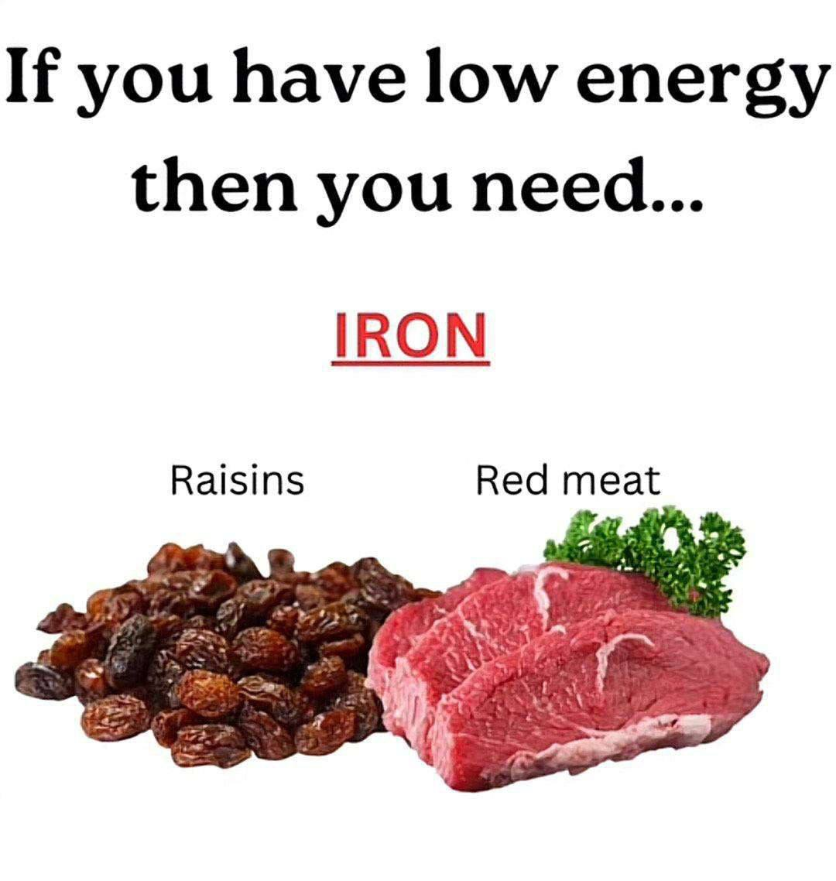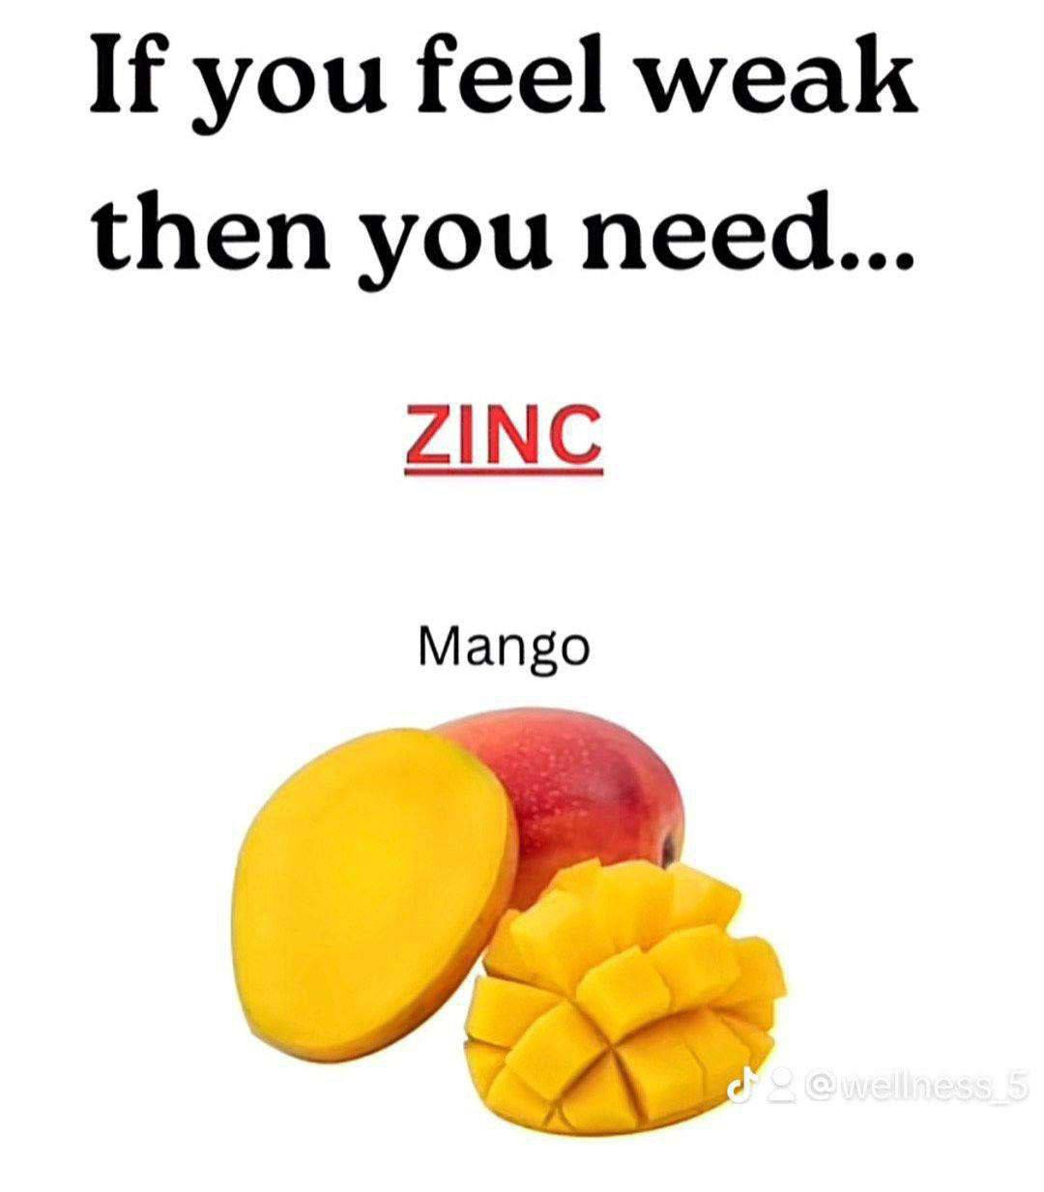

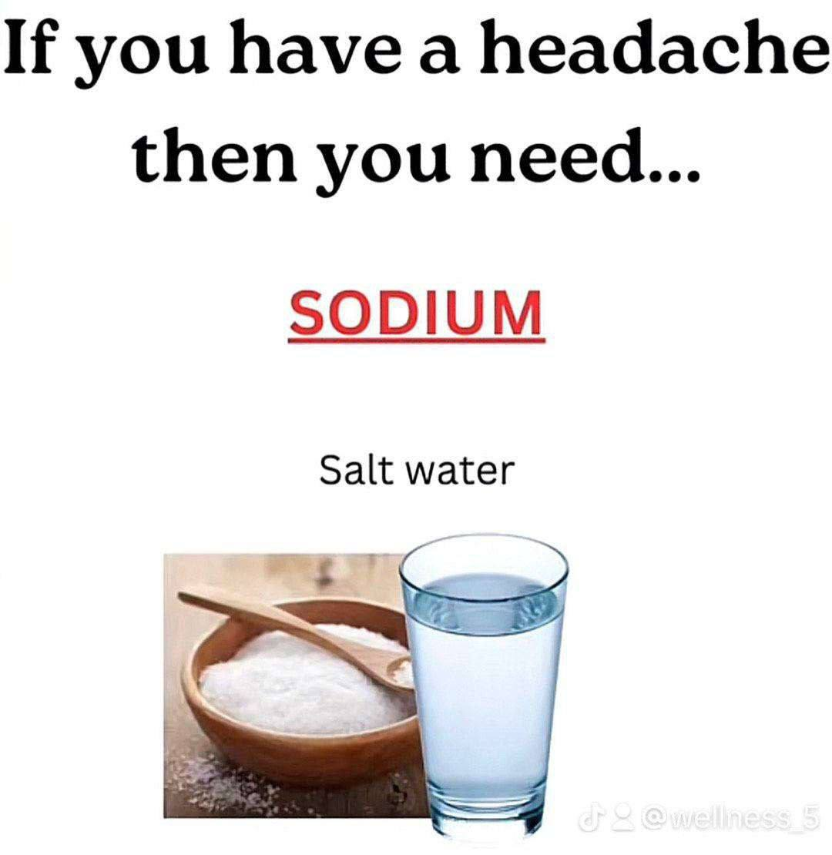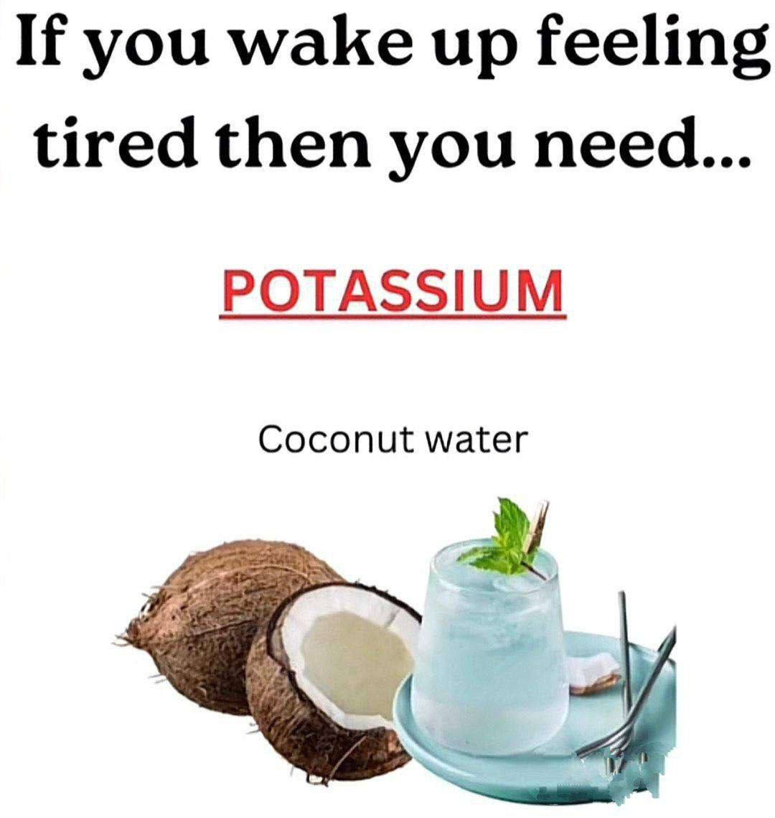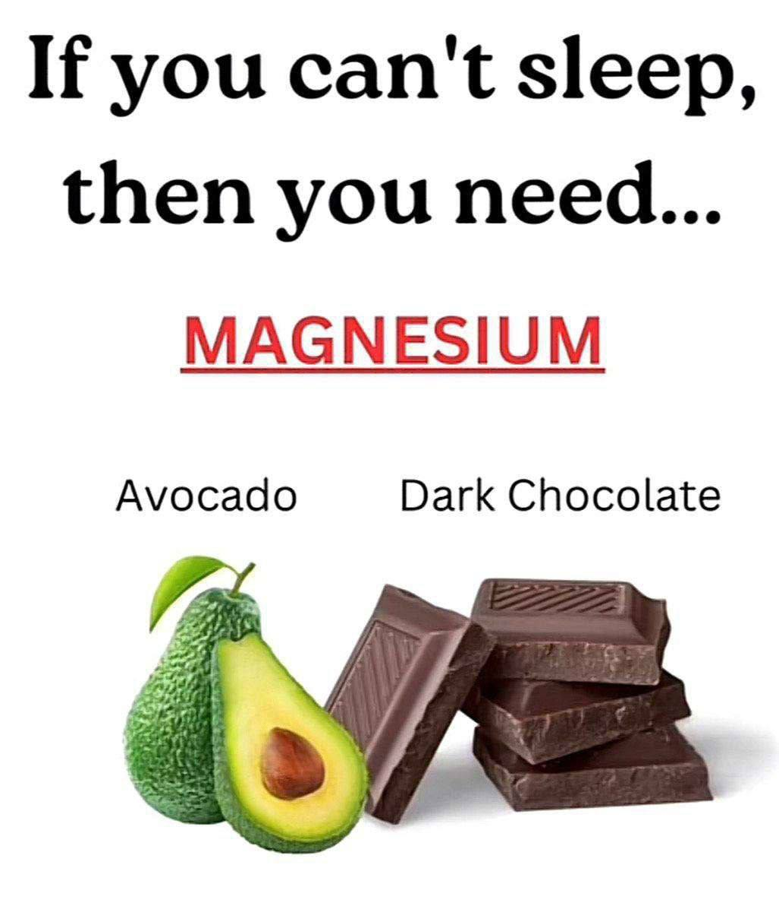

⚡**️ DEFICIENCIES & MISSING MINERALS & VITAMINS**

• CRACKED LIPS - Iron, vitamin C

• DANDRUFF - Biotin, vitamin B7

• THINNING HAIR - Iron, vitamin C

• ACNE - Zinc

• GREASY SKIN - Zinc, vitamins B2, B6

• BRITTLE NAILS - Iron

• COLD HANDS / FEET - Anemia (iron)

• PSORIASIS - Zinc, vitamin D

• ITCHY / DRY SKIN - Omega 6• HEADACHE - Magnesium, Vit B6, B12• BAD BREATH - Iron• MOUTH ULCERS - Iron, folic acid, Vit B6, B12 • PMS - Magnesium, estrogen

• LOW LIBIDO - Vitamin D

• DEPRESSION / ANXIETY - Magnesium, calcium & vitamins B, D

• STRESS - Magnesium & zinc

• JOINT PAIN - Magnesium, potassium, sodium, vitamins B1 and D

🌸 MINERAL CHEAT SHEET:

• Magnesium = energy/sleep/bone

• Potassium = blood pressure

• Salt = hydration/digestion

• Copper = collagen/iron

• Selenium = immunity

• Chromium = blood sugar

• lodine = thyroid

• Iron = oxygen

• Manganese = glucose

• Calcium = muscle/bone health

• Zinc = immunity

Join Health Secrets - by Barbara O'Neill! (https://t.me/BarbaraONeillHealth) Telegram Channel! ✅️