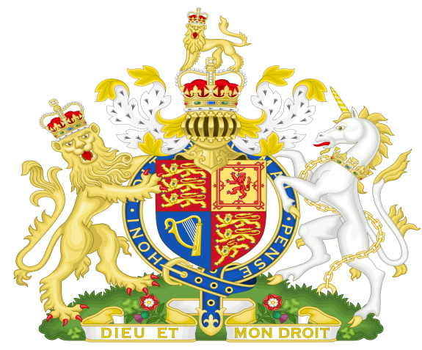

**Statement of Evidence to Obtain the Attached Warrant and Place**

**The named Offender in Custody Pending Trial**

**by Grand Jury of his or her piers**

1. **The said Offender is a member of an Unlawful Political Party operating**

**under the Australia Act 1986 without Lawful Authority.**

1. **The Australia Act 1986 was not put to The People by Referendum**

**under 128 of Our Commonwealth Constitution Act 1900 UK and**

**The Commonwealth Constitution 1901 and so is Unlawful.**

1. **There could be no conferral of the States as every State had**

**REMOVED their original Constitutions and REPLACED them with**

**Unlawful Constitutions contrary to 106 of the Commonwealth**

**Constitution Act 1900 UK and the Commonwealth Constitution 1901.**

1. **Pursuant to Clause 7 of Our Constitution there was no authority**

**granted by Section 51 ss xxxviii of the Commonwealth Constitution**

**1900 UK or our Commonwealth Constitution 1901**

**Ref Page 651 Q & G (b).**

1. **The said Political Parties created the Queen of Australia using the**

**Australia Act 1986 and declared the Commonwealth as a Sovereign**

**Independent and Federal Nation without compliance with 128 of**

**The Commonwealth Constitution Act 1900 UK and The**

**Commonwealth Constitution 1901.**

1. **The Political Parties that the OFFENDERS belong to were Privy to and**

**operated under the Letters Patent proclaimed by BOB HAWKS**

**(PRIME MINISTER) on the 24th of August 1984 by a Fraudulent**

**command of the Reigning Monarch of this country,**

**therefore waging war on the Monarch and Her People.**

1. **In 2020 the Offenders CONSPIRED TOGETHER to form a**

**NATIONAL CABINET without consent of The People by 128 of the**

**Commonwealth Constitution Act 1900 UK and**

**Our Commonwealth Constitution 1901.**

1. **This NATIONAL CABINET took control of The People who are**

**The Commonwealth, and put them into SLAVERY BY**

**DICTATORIAL RULE contrary to 268 ss 10, 11 and 12**

**of the Commonwealth Crimes Act.**

1. **The NATIONAL CABINET set aside the Commonwealth**

**Constitution Act 1900 UK and the Commonwealth Constitution 1901**

**again WAGING WAR ON THE Crown and The People who are**

**The Commonwealth of Australia contrary to the 1999 Referendum at**

**which The People voted to retain the Crown and**

**Our Lawful Constitution.**

1. **The OFFENDERS were Warned of THEIR CRIMES**

**on the 7th of January 2019 when a Commonwealth Public**

**Official who Seized the Three Tiers of The lawful Federal**

**Parliament the Unlawful GREEN POLITICAL PARTY**

**CONSTITUTION all of THEIR PURPORTED ACTS**

**and STATUTES and all of the Assets of The People and**

**Crown, The People who are The Commonwealth now Hold**

**all of the above in Adverse Possession under the Crown**

**until the POLITICAL PARTIES prove otherwise –**

**Simply THEY CAN NOT.**

1. **Lawful Documents explaining the above Seizure were**

**served on Scott Morrison The Federal Parliament and on**

**the House of Lords England by email and Registered Post.**

1. **The House of Lords per Lord Fowler, the Lord Speaker**

**Accepted the Documents and sent a return email stating**

**they would look into the situation.**

1. **On the 10th of December 2021 The People through Velvet**

**Revolution Served The Lawful Moratorium on every**

**Parliament House in the Commonwealth of Australia, every**

**Governor and The Governor-General ordering them to**

**comply by the 18th of December 2021 to The Will of The**

**People who are the Commonwealth.**

1. **On the 18th of December 2021 Notices were placed on all Public**

**Building belonging to The People who are the Commonwealth,**

**ordering all POLITICIANS and members of the**

**POLITICAL PARTIES to remove themselves from Our Buildings.**

**Dated:**

**Signature**

**_________________________**

**Name**

**__________________________**

**Witness**