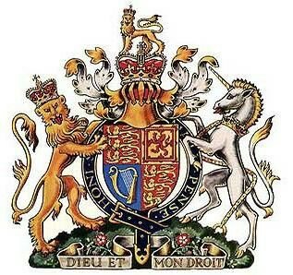

**Affidavit of Truth**

**Name of Affiant:**

**Address:**

**Primary Respondent:**  David Hurley – Governor General

**Address:** Government House, Dunrossil Drive Yarralumla ACT 2600.

I NAME, solemnly swear, declare and depose that the evidence that I present in this Affidavit is the truth.

By way of the Australia Act 1986, an unlawful act was perpetrated against the good citizens of the Commonwealth of Australia in that the Federal Parliament in agreeance with the States overturned the Constitution of the Commonwealth of Australia 1900 UK.

This charge is a capital offence and there will be further charges pending.

Dated this DAY of the month know as MONTH, two thousand and twenty-two.

**Affiants Autograph: Witness Autograph:**