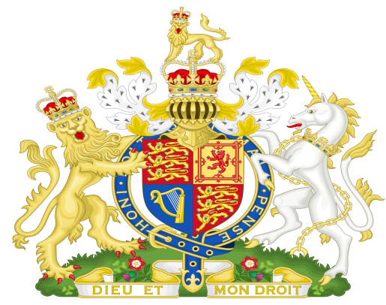

To The Honourable Justices of the High Court of England

And to All Members of the House of Lords

Dear Sirs & Mam,

I write to you as a Loyal Subject of Her most excellent majesty Queen Elizabeth the II Queen of Great Britain and Northern Ireland, Defender of the Faith, Lawful Monarch of the Colony of Australia known as the Commonwealth of Australia.

As you are aware we were formed under the Commonwealth Constitution Act 1900 UK as proclaimed and Gazetted on the 9th of July 1900.

We, the people of the Six Colonies joined together as One Colony under your Act which We Accepted by Referendum as Our Constitution.

I wish to advise you that the Company known as the Australian Government has usurped Her majesty’s Authority and taken over Her Realm contrary to The Will of Her Subjects and has Stolen all of Their Property and Rights Granted by Her Majesty.

We The people of the Commonwealth, Her Majesty’s Subjects, Request you to intervene and bring these people to Justice for the Crimes against Her Majesty and us, Her People.

Respectfully advised by;

Name:

Address:

Signed

Dated:

Send to – The Supreme Court

The Honourable Justices of the High Court of England

Little George St, Westminster, London SW1P 3BD, United Kingdom

The Strand London England